|  |  |
| --- | --- |
|  |  |

|  |
| --- |
| Forecast using neural network user guide |
|  |

# Neural networks a brief introduction:

Artificial neural networks were proposed in 1943 by Warren McCulloch and Walter Pits when they created a computational model for neural networks based on mathematics and algorithms called as threshold logic. Neural networks received renewed attention after backpropagation, a method to effectively solve exclusive-or problem was discovered by Werbos in 1975. Backpropagation also accelerated the training of multilayer networks, which worked by distributing the error term back up through the layers, by modifying the weights at each node.

# Visual Description

The visual uses neural network algorithm to forecast future values based on historical data.

# Overview

Forecast the future values based on the historical data by employing Neural Network algorithm for time series forecasting. Forecasting is useful for a variety of professions spread over numerous fields, be it budget, sales, demand or inventory. Better forecasts of future lead to better and more well-informed decisions. Forecasting using Neural Network implements an ‘Artificial Neural Network’ to learn from observed data over a time to predict the values of future.

It employs a single layer feed forward network with lagged inputs to deal with time series values.

Key features include:

* Ability to use years or distinct numerical values in place of Date/Date & Time field. (The visual will work for both numerical series i.e. years/numbers and proper Date/Time values).
* The ability of hover tooltips and highlighting a portion of the plot.
* Capability to manually adjust the parameters of the learning model.
* Zoom in/out capabilities over any point on the plot.
* Downloading a screenshot of the plot as an image.

# Example

Let’s assume that the strategic planning team of an organization wants to know future sales of their organization.

Now, we can simply use Forecast using neural networks visual to analyze historical data and give a prediction of future sales for the organization. To get the forecast, we simply must supply the visual with historical sales data in the form of two data fields -

* “Series/Date” field should be supplied with a series value that denotes the order of occurrence of values
* “Values” field, which represents the magnitude of the variable to be predicted with respect to the values supplied in the previous field

Both the fields are essential to the visual’s functionality.

The resulting chart will give a line plot of observed and forecasted values as shown in the below image.

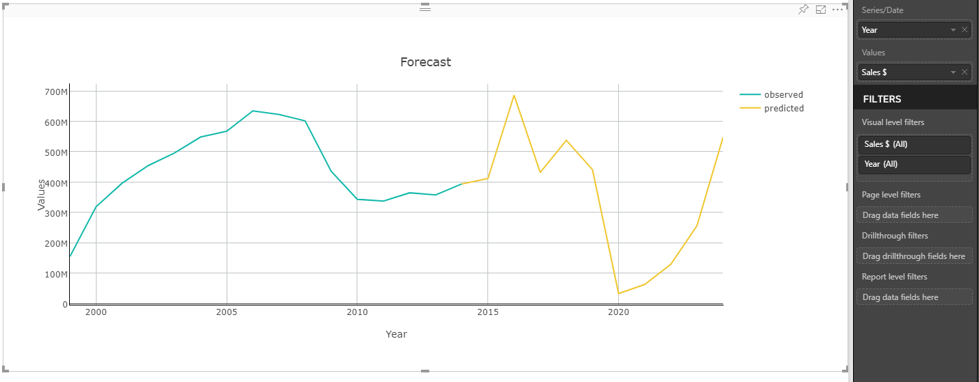

1. **Forecast settings**: The following parameters provided to the NN model can be modified in “Forecast settings” as per the convenience and requirement of the user -
   1. **Decay -** Decay is the value by which the weights on every node are adjusted over subsequent iterations so that large weights are penalized, and small weights are free to grow thereby improving generalization of the model.
   2. **Epoch** - Epoch represents the number of times entire training process is repeated. Hence it is a measure of the number of times all the training vectors are used once to update the weights.
   3. **Maximum iterations -** It represents the maximum number of training iterations in a single epoch.
   4. **Size -** Size denoted the number of nodes in the hidden layer of the network.
   5. **Confidence intervals** - Turn confidence intervals ON or OFF.
   6. **Confidence levels -** It determines the confidence level of the confidence interval displayed.

The user can also use automatic settings if he wants to set these parameters automatically to the optimum value.

Note- User should set the parameters cautiously as extreme parameter values may cause overfitting.

1. **Plot settings:** The user can also control the appearance of the plot such as the color of plot lines labels and threshold colors by using plot settings. To do this the user needs to change the default settings for the respective plot element.
2. **X-axis settings:** The user can control the behavior of chart elements on x-axis such as x labels, grid lines for the x-axis, their colors etc. by using “X-axis settings”.
3. **Y-axis settings:** The user can control the behavior of chart elements on x-axis such as y labels, grid lines for y-axis, their colors etc. by using “Y-axis settings”.

